Montecito Investment Portfolios

January 1, 2011

Dear Fellow Investors,

The Depression has been canceled, but the Great Recession is not over.

We hope that New-Year 2011 sees you in good health and full of optimism going forward. We are pleased to report that the disciplines we invest by have proven themselves over the last few years. By providing sustainable and forecastable income in the form of dividends and interest to our investors we were able to weather the toughest volatility in the investing markets our generation has seen. We are pleased to report that the majority of our investors remained true to their long term investment plans and now have account values at or near all time high valuations – even with the Dow Jones Industrial average still over 2,000 points below its highs.

Certainly there is reason for optimism with the worst seemingly being behind us. However, being in Fresno, away from the “Masters of the Universe” and the incestuous nature of the thought process and Ideas of Wall Street, allows us to cull through the same information and step back and assess it free from the chatter. As a result, sometimes we don’t agree with the consensus view because to us it just doesn’t make common sense. Wall Street says the recession is over, that it ended in the fourth quarter of 2009. We disagree. Certainly the Gross Domestic Product (GDP) has shown growth over the past four quarters and that is the economic yardstick for labeling the economy but we believe the GDP growth was “purchased” by the Federal Reserve and does not represent as yet sustainable real economic growth. We offer the following as our empirical proof we are still in a difficult economic time that fundamentally is struggling.

- Unemployment is rampant in America. We have included a chart (Chart 1) of both the “Official” unemployment, and the broader U6 number which tracks those without a job. When nearly one in 5 employable people are under-employed or not working, we think this is a sign of a struggling economy

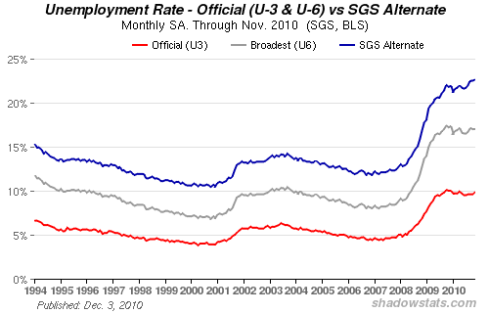
Chart #1 - Courtesy of ShadowStats.com

- The Federal Reserve is making money available at the lowest possible rate – 0 to ¼% - and the Money supply is still shrinking (Chart 2). Corporations and banks are deleveraging faster than the government can expand their balance sheet and prevent wholesale deflation. Ask yourself the question – Do you know any business that is adding debt presently?

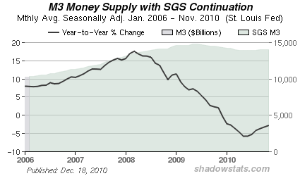
Chart #2 - Courtesy of ShadowStats.com

- Housing prices have still not stabilized and the backlog of foreclosures and unsold homes remains at very high levels. Many banks are requiring more than 20% down to even consider writing a home loan.
- Banks are now secured asset lenders and presently not investing with companies in growth.
- State and Municipal finances are a mess and many cities and agencies are considering bankruptcy. Even without bankruptcy filings there are continued furloughs and cuts in services.
- The specter of the US Dollar losing its status as the world’s reserve currency

While harsh realities should not be ignored, history has shown us the best time to invest is not when optimism rules the day (As was the case in 2000 or 2007) but rather when there are legitimate concerns that need to be overcome. Each of these negatives has a corresponding solution that could be positive in the future. It will take time however to work through these problems which we welcome as we are long term investors, and not short term speculators. We know that with life expectancy extending, and people investing not just for themselves, but for the next generation as well, a true investor’s time horizon is measured in years and decades, not days, weeks and quarters. Let’s look at the flip side of these harsh realities…

- Unemployment is improving and we have a labor pool ready to work for reasonable wages. We feel the worst is behind us and as people find jobs, confidence will improve.
- The Federal Reserve did a masterful job of reacting with speed and necessary liquidity to stave off a deflationary spiral that could have imploded our financial system much like the 1930’s. Now corporations have been able to refinance debt at lower levels, raise cash, and improve their balance sheets. Our major banks have been solidified and the base of capital is set to fund growth into the future.
- Population growth continues in the United States through births and immigration. As it does there are new household formations that will be absorbing the inventory of homes. With mortgage rates as low as they are, owners of homes have a unique opportunity to fix their “Rent” at more affordable levels. And homebuilders have reined in construction to allow for a work off of existing inventory. House’s are selling below replacement cost and mortgages are the same payments as rent (Chart 3). The price decline is either at or very near the bottom (Chart 4). It is a slow road back to improving values, but we believe the corner has been turned.

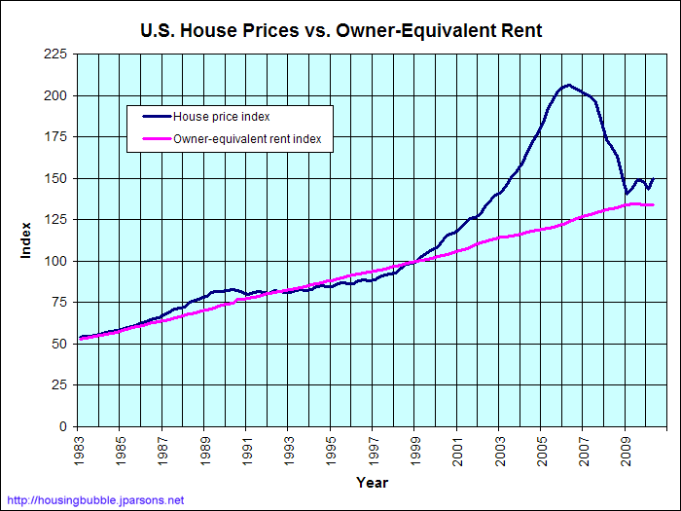
Chart 3
Courtesy of Big Charts.com

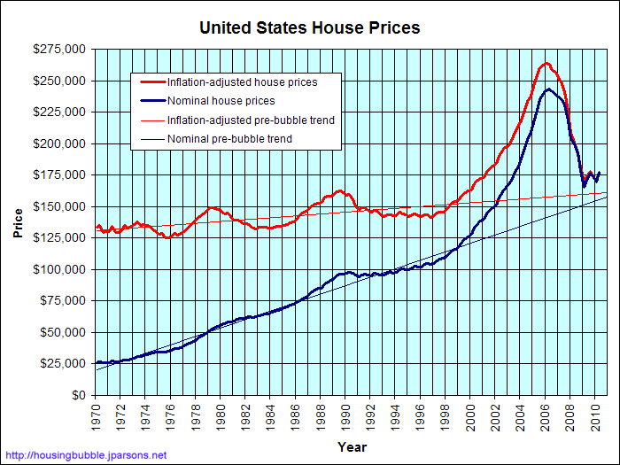
Chart 4
Courtesy of BigCharts.com

Charts 3 and 4 estimates the market value of today's median-priced house over time. The trailing nominal prices are derived by taking the recent median price of existing single-family homes, as reported by the National Association of Realtors, and discounting it by the S&P/Case-Shiller National Home Price Index. From 1975 through 1986, the FHFA House Price Index is used. From 1970 through 1974, the Freddie Mac Conventional Mortgage Home Price Index is used. The S&P/Case-Shiller HPI, FHFA HPI, and Freddie Mac CMHPI are "constant quality" indices, so even though houses are built larger today than they were many years ago, this graph automatically adjusts for this variation. The trailing inflation-adjusted prices are then derived by adjusting the nominal prices by the CPI-U Research Series Using Current Methods. Prior to Q4 1977, the CPI - All Items Less Shelter is used. (Source BigCharts.com)

- Banks have embraced conservative lending practices and become the conscious partner to reign in corporate speculation. This implies higher quality and more predictable corporate profits going forward.
- States and Municipalities dealing with bloated payrolls and excess services may be the first wave of bringing common sense back to government. While we think there may be extreme headline news coverage on this subject in the coming year, we feel the Federal Government will act in the same manner as the European Union and provide bailout funds for the states that need it. But, at a cost. The cost will be fiscal austerity. We feel they should get to it sooner rather than later. As one of our partners said, “Pull the band-aid off quickly and get it over with and behind us”.
- The US as a reserve currency has served its purpose since the end of the Second World War. Now finance, trade, and economics are global in nature. As such the economic currency should be more completely integrated to create a stable, level playing field. Yes there will be some disruptions of imports and exports in adapting to a new reserve basket of currencies, but in the end innovation and knowledge will still provide organic growth.

So now we get to that section of an annual state of the markets letter where we do the most foolish thing an investment manager can do – make forecasts. Without the aid of a crystal ball there are too many changing influences and surprises that erode our fortune telling capabilities. However, we are going to attempt dabbling in the ancient art of forecasting.

We still run our portfolios from the bottom up – focusing on the individual investments themselves, knowing that over time if we do our work well, carefully chosen investments should provide the returns we are looking for – regardless of the short-term volatility of the market. Let’s review last year’s forecasts and update them with our look forward for 2011

Last year we forecasted that interest rates would start to rise in 2010. Certainly the Federal Reserve has kept short-term rates at artificially low levels to keep liquidity in the financial system. Currently the 10-year yield is below where we came into 2010. So we certainly got that prediction wrong! But even in the face of Quantitative Easing 2 the longer-term rates, after declining in the middle of the year, have started to move back to the levels of 2008 and 2009. We feel the major multi-decade secular move down in interest rates is over. Sometime soon we believe a new trend will occur in interest rates– one of gradually increasing rates. We forecast this rising trend will last for a decade or longer and eventually take us to double digits again. Don’t panic, that may be twenty years from now. Our forecast for 2011 is that the bottoming process will be completed and this trend we are looking for will begin. So rates on the U.S. 10-year Treasury Notes will be higher at year-end 2011.

Last year we forecasted the stock market would be up single digits in 2010. The Standard and Poor’s 500 with dividends reinvested was up 15.26% according to Thomsen Reuters in 2010. So even while we had the direction correct (up) we missed on the magnitude. Our thesis of rising interest rates leading to P/E Compression never materialized. With the Federal Reserve’s desire to maintain liquidity, investment capital found was placed for higher returns. In 2011 the good news of a slowly growing economy, will finally allow for the Fed Funds rate to come off the floor. When it does, we think the markets will anticipate and factor in PE Compression. Fortunately there will be higher corporate profits to offset the PE Compression and higher dividend payouts as well. In 2011 we see the stock market up by single digits.

Last year we predicted that Commercial Real Estate would hit its trough in the first half of the year. We have to say that the jury is still out on when the trough will have been put in. We can say the deal flow appears to have bottomed. We agree with our industry sources that it is anticipated to pick up strongly in 2011. Further, we see evidence that lending (at appraisal levels based on higher cap rates) has already picked up. But, rent roll backs on expiring leases are still an issue that needs to be dealt with in many areas. Our sources tell us that stabilization of pricing may have occurred this year but there is still a huge need for economic activity to pick up to maintain these levels. Our prediction for this year – commercial real estate will see a flat year and a longer bottoming process.

We are not going to shy away from controversy in this letter. So we are going to put in print a few things that are longer-term forecasts – knowing that anything can happen, we presently feel these could very well come to pass during this decade. It is a fun exercise designed to simulate conversation and five years from now we will look back and have fun with it over a glass of wine.

- The government will not shrink on an absolute basis, but will institute mandates that will keep it from growing more than the economy until such time as it shrinks to a reasonable percentage of GDP. According to guest analysts on Bloomberg radio, during the Clinton and Bush administrations the government was under 20% of GDP. They state that presently it is closer to 25%. We believe that is unsustainable. A recovery in the economy without a corresponding growth of government would bring that ratio back in line. But to bring the balance sheet of the United States back to true AAA status we feel will require us taking government to closer to 16% of GDP in twenty years – We think the lessons we are learning now will lead to that outcome.
- Corporate Tax rates will decrease substantially. There will be a massive overhaul of the tax code in the United States in order to make us more competitive in the world economy. Presently we are the second highest corporate tax rate in the world. That will be adjusted down.
- Individual Absolute taxes paid will increase. We see all deductions being eliminated and current brackets maintained. This will be done as an austerity measure to pay for the emergency indebtedness that was created during the “Great Recession of 2008 through 2013”
- Every entitlement program in the United States will become means tested. Anyone in the top 10 percent of income earners will get no benefits. Those between 10 and 20 percent will get a reduced benefit.
- Interest Rates on the ten-year bond will be twice what they are now by the end of the decade.
- The US Dollar will not be the reserve currency for the world.
- As the lexicon of finance has embraced new levels of monetary largess during my career (Millions to billions to Trillions) it will continue and we will be using Quadrillion in everyday speech by the end of the decade.

As we finish this rather lengthy annual letter - let us apologize for the length – quarterly updates should be much shorter. Hopefully there is a nugget or two that you find of value. Let us leave you with a few “Simple Truths” or “Today’s Realities” from our perspective;

- The dividend yields on many great multinational corporations are higher than the 10-year bond yield.
- Bonds have no upside – Equities can grow
- Equity valuations eventually will reflect inflation – Bonds simply lose purchasing power with inflation
- As the population grows, so does the overall economy – and the birthrate and immigration are growing our population
- Baby Boomers are not retiring (they can’t afford to) and will be working longer.
- Baby Boomers are getting older, and elder services will be a growth area of the economy.
- Mortgage Rates are historically low (If you have not already done so we suggest you refinance into fixed rate mortgages)

Again we want to thank you for your continued confidence and the opportunity to manage your investments. We take very seriously our responsibility and will always endeavor to be responsive to your questions and concerns. We welcome and encourage your comments as well.

Montecito Investment Portfolios Mission: To provide diversified, disciplined, long-term investment solutions, service and guidance for helping our clients achieve their “Financial Independence”.

Blake Todd Jarrett Perez
Portfolio Manager Assistant Portfolio Manager

And Now a word from our sponsors with Important Disclosures
This Annual letter expresses the personal views of the author and Montecito Investment Portfolios on the current and future economic and investment landscape, at this date. It is subject to change and is not necessarily the opinion of Crowell, Weedon & Co. or its Partners.
The information contained in this presentation has been taken from trade and statistical services and other source, which we believe to be reliable. We do not guarantee that this information is accurate or complete and it should not be relied upon as such.
This presentation is for informational and illustrative purposes only, and is not intended to meet the objectives or suitability requirements of any specific individual or account. An investor should assess his/her own investment needs based on his/her own financial circumstances and investment objectives.
The predictions, projections, or other information generated by the author regarding the likelihood of various future outcomes are hypothetical in nature, do not reflect actual investment results and are not guarantees of future results.
Neither this presentation, nor any chart or graphs within this presentation may be used, in or of themselves, to constitute investment advice. They are for informational and educational purposes only.
There are risks inherent in any investment and there is no assurance that any money manager, asset class, style or index will provide positive performance over time. The investment return and principal value of an investment will fluctuate, so that an investor’s shares, when redeemed, may be worth more or less than their original cost.
The Dow Jones Industrial Average is a price-weighted average of 30 significant stocks traded on the New York Stock Exchange and the NASDAQ.
The Standard & Poor’s 500 is a capitalization weighted index comprised of 500 widely-held stocks on US stock exchanges.
Quantitative Easing 2 – The second round of the Federal Reserve’s monetary policy used to stimulate the U.S. economy following the recession. The Fed creates money which it uses to buy government bonds and other financial assets in order to increase the money supply.
PE Compression – The effect that arises when a stock trades at a certain multiple and, while earnings may be strong, the stock price doesn't move up (or even goes down). The result is that the given multiple (P/E ratio) is reduced even though nothing is fundamentally wrong with the company. Compression of a company's multiple can be interpreted as the valuation being called into question.

